GTB  
  
**QA**  
[DEV 21.16] OT-1152 | XT | NL | BP | 3.0 Popin - NGC (TDR)

**Jira ticket:**  
<https://jira.uhub.biz/browse/GTBEMEAOPT-1152>

**Site**  
<https://www.ford.nl/>

**Test location**  
Across certain pages on [www.ford.nl](http://www.ford.nl/) (see below)

**Test Description**

There are 2 parts to this ticket:

1. Collecting the Data
2. Displaying the popup

It must happen in that order.

**Collecting the Data:** View the QA Link, click on “*MODELLEN*” on the main navigation bar. To start the configuration journey, click on the link below the intended vehicle – “*Sammenstellen*”. You will now be at the beginning of configuring for that vehicle. Configure the vehicle by going through the steps of selecting all your desired specifications until you reach the summary page. Upon reaching the summary page - you should leave in order to trigger the TDR popup from the list of locations and conditions below.

**Extra**: Please check for any errors you find in the console. You’ll know which errors are ours by comparing the location of the error to a message that may have appeared earlier. See the below image as an example that contains 1 error.

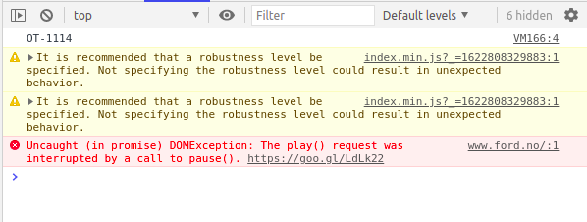

Looking at the above, the error is the 4th message in the image, and it’s location is [www.ford.no/:1](http://www.ford.no/:1) ~The first line on that page. Our script also left a message, the OT-1114, which is located in VM166:4 ~ The message was executed from VM166 on line 4. Thus if our scripts had any errors, it would’ve been displayed with the location as VM166:XXX ~ Where XXX represents the line of the error.

**Displaying the Popup:** The popup can display in multiple locations if certain conditions are met.

* Homepage
* NPP of relevant vehicle (eg Fiesta popin to only appear on Fiesta NPP)
* Model Pages of relevant vehicle
* If vehicle is present in Mini Showroom -> Commercial Vehicles, then show also on Commercial Vehicles page(see Thin Header on Showroom for link)
* Appear in PV promotions only if it is a personal vehicle
* Appear in CV promotions only if it is a commercial vehicle
* Appear in CV landing page only if commercial vehicle
* If vehicle is present in Mini Showroom -> SUV & Crossover, then show also on SUV page (see footer on Homepage for link)
* If vehicle is present in Mini Showroom -> Hybrid Electric, then show also on Hybrid Electric page (see footer on Homepage for link)
* If vehicle is present in Mini Showroom -> Family Cars, then show also on Family Cars page (see footer on Homepage for link)
* If vehicle is present in Mini Showroom -> Performance, then show also on Performance page (see footer on Homepage for link)
* If vehicle is ST-line, then show also on ST-line page (see footer on Homepage for link)
* If vehicle is Fiesta, Ecosport or Puma, then show also on Small Vehicle page (see footer on Homepage for link)
* If vehicle is Tourneo Courier, Tourneo Connect, S-Max, Galaxy or Tourneo Custom and Transit Bus, then show also on People Carrier page (see footer on Homepage for link)

The popup can only appear a maximum of 3 times, with a 15 minute duration in between popups. Popups appear after 15 seconds of landing on the page. The CTA will direct you to a Send to Dealer page, with the vehicle pre-selected.

**NOTICE:** Ford has upgraded this site (NETHERLANDS) to a newer style. Some of the above locations/pages may no longer be there or easy to find.

The Popup:  
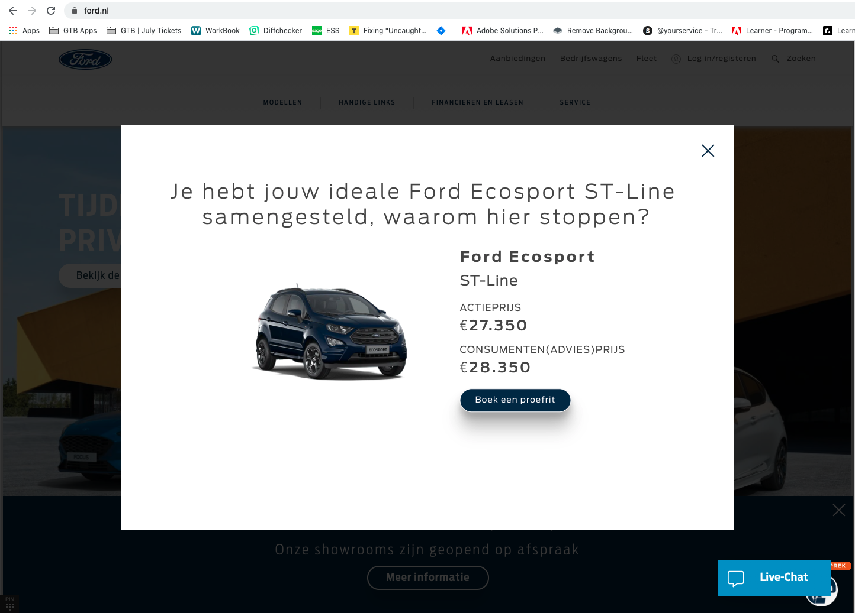

**Content of the Popin:**

Heading: Je hebt jouw ideale [NAMEPLATE] samengesteld, waarom hier stoppen?

CTA: Boek een proefrit

Price Information is pulled from the BP journey and could be different for every vehicle.  
  
**NOTE:** No disclaimers available.

**Browser:**   
All  
  
**Device:**   
All  
  
**Audience rules:**   
All traffic

**QA Links:**

<https://www.ford.nl/?at_preview_token=0eWHiCgR9i_xcm0IbpEGbA&at_preview_index=1_1&at_preview_listed_activities_only=true>